1. **FIRST COURSE**

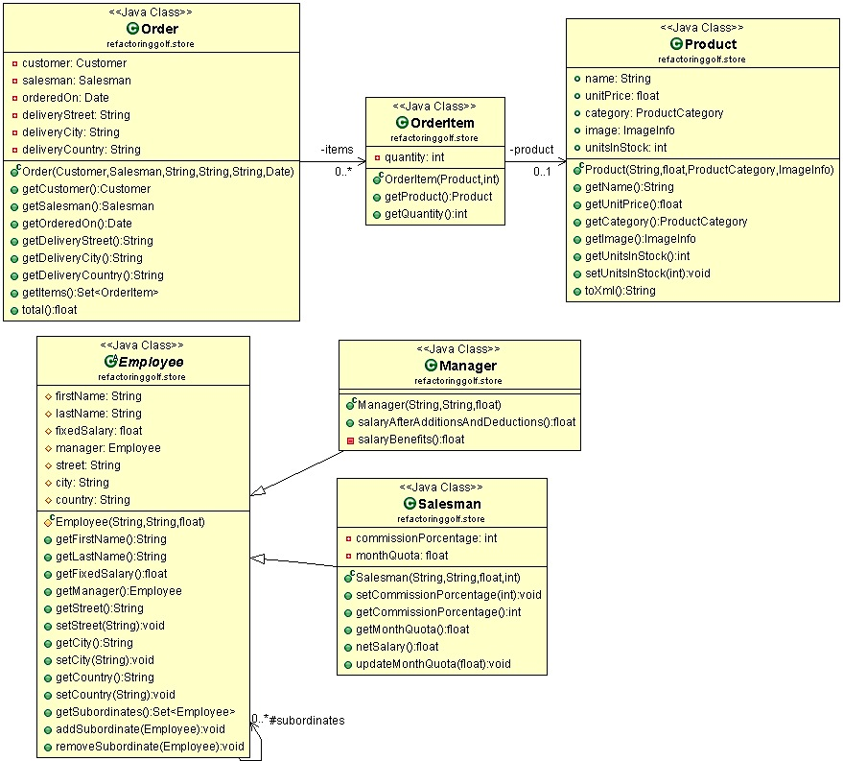

**INITIAL TEE**

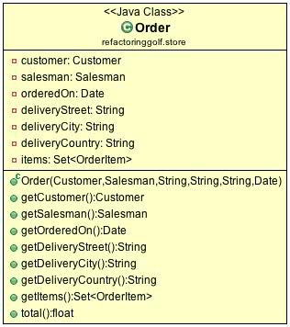

**public** **class** Order {

**public** **float** total() {

**float** totalItems = 0;

**for** (OrderItem item : items) {

**float** totalItem=0;

**float** itemAmount = item.getProduct().getUnitPrice() * item.getQuantity();

**if** (item.getProduct().getCategory() == ProductCategory.*Accessories*) {

**float** booksDiscount = 0;

**if** (itemAmount >= 100) {

booksDiscount = itemAmount * 10 / 100;

}

totalItem = itemAmount - booksDiscount;

}

**if** (item.getProduct().getCategory()== ProductCategory.*Bikes*) {

// 20% discount for Bikes

totalItem = itemAmount - itemAmount * 20 / 100;

}

**if** (item.getProduct().getCategory() == ProductCategory.*Cloathing*) {

**float** cloathingDiscount = 0;

**if** (item.getQuantity() > 2) {

cloathingDiscount = item.getProduct().getUnitPrice();

}

totalItem = itemAmount - cloathingDiscount;

}

totalItems += totalItem;

}

**if** (**this**.deliveryCountry == "USA"){

// total=totalItems + tax + 0 shipping

**return** totalItems + totalItems * 5 / 100;

}

// total=totalItemst + tax + 15 shipping

**return** totalItems + totalItems * 5 / 100 + 15;

}

}

**FIRST HOLE**

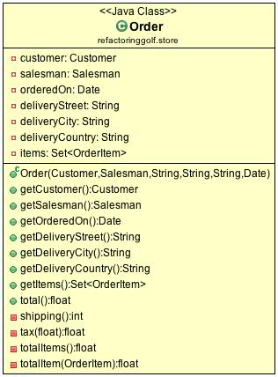

**public** **class** Order {

**public** **float** total() {

**float** totalItems = totalItems();

**float** tax = tax(totalItems);

**int** shipping = shipping();

**return** totalItems + tax + shipping;

}

**private** **int** shipping() {

**int** shipping = 15;

**if** (**this**.deliveryCountry == "USA") {

shipping = 0;

}

**return** shipping;

}

**private** **float** tax(**float** totalItems) {

**return** totalItems * 5 / 100;

}

**private** **float** totalItems() {

**float** totalItems = 0;

**for** (OrderItem item : items) {

totalItems += totalItem(item);

}

**return** totalItems;

}

**private** **float** totalItem(OrderItem item) {

**float** totalItem=0;

**float** itemAmount = item.getProduct().getUnitPrice() * item.getQuantity();

**if** (item.getProduct().getCategory()==ProductCategory.*Accessories*) {

**float** booksDiscount = 0;

**if** (itemAmount >= 100) {

booksDiscount = itemAmount * 10 / 100;

}

totalItem = itemAmount - booksDiscount;

}

**if** (item.getProduct().getCategory() == ProductCategory.*Bikes*) {

// 20% discount for Bikes

totalItem = itemAmount - itemAmount * 20 / 100;

}

**if** (item.getProduct().getCategory() == ProductCategory.*Cloathing*) {

**float** cloathingDiscount = 0;

**if** (item.getQuantity() > 2) {

cloathingDiscount = item.getProduct().getUnitPrice();

}

totalItem = itemAmount - cloathingDiscount;

}

**return** totalItem;

}

}

**SECOND HOLE**

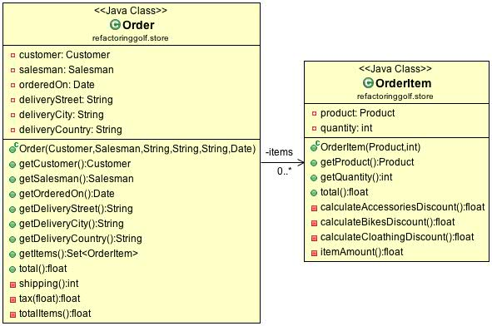

**public** **class** Order {

**private** **float** totalItems() {

**float** totalAmount = 0;

**for** (OrderItem item : items) {

totalAmount += item.total();

}

**return** totalAmount;

}

}

**public** **class** OrderItem {

**public** **float** total() {

**float** discount = 0;

**if** (getProduct().getCategory() == ProductCategory.*Accessories*) {

discount = calculateAccessoriesDiscount();

}

**if** (getProduct().getCategory() == ProductCategory.*Bikes*) {

discount = calculateBikesDiscount();

}

**if** (getProduct().getCategory() == ProductCategory.*Cloathing*) {

discount = calculateCloathingDiscount();

}

**return** itemAmount() - discount;

}

**private** **float** calculateAccessoriesDiscount() {

**float** discount = 0;

**float** unitPricePerQuantity = itemAmount();

**if** (unitPricePerQuantity >= 100) {

discount = unitPricePerQuantity * 10 / 100;

}

**return** discount;

}

**private** **float** calculateBikesDiscount() {

**return** itemAmount() * 20 / 100;

}

**private** **float** calculateCloathingDiscount() {

**float** discount = 0;

**if** (getQuantity() > 2) {

discount = getProduct().getUnitPrice();

}

**return** discount;

}

**private** **float** itemAmount() {

**return** getProduct().getUnitPrice() * getQuantity();

}

}

**THIRD HOLE**

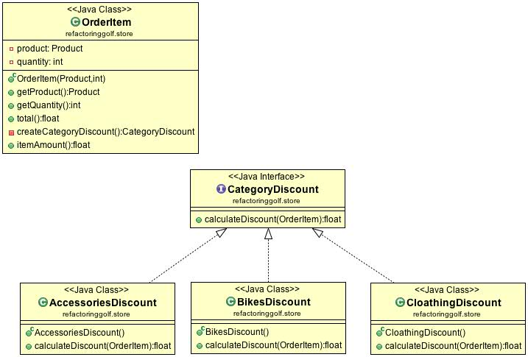

**public** **class** OrderItem {

**private** CategoryDiscount createCategoryDiscount() {

CategoryDiscount categoryDiscount=**null**;

**if** (getProduct().getCategory() == ProductCategory.*Accessories*) {

categoryDiscount = **new** AccessoriesDiscount();

}

**if** (getProduct().getCategory() == ProductCategory.*Bikes*) {

categoryDiscount = **new** BikesDiscount();

}

**if** (getProduct().getCategory() == ProductCategory.*Cloathing*) {

categoryDiscount = **new** CloathingDiscount();

}

**return** categoryDiscount;

}

}

**public** **interface** CategoryDiscount {

**float** calculateDiscount(OrderItem orderItem);

}

**public** **class** AccessoriesDiscount **implements** CategoryDiscount {

**public** **float** calculateDiscount(OrderItem orderItem) {

**float** discount = 0;

**float** unitPricePerQuantity = orderItem.itemAmount();

**if** (unitPricePerQuantity >= 100) {

discount = unitPricePerQuantity * 10 / 100;

}

**return** discount;

}

}

**public** **class** BikesDiscount **implements** CategoryDiscount{

**public** **float** calculateDiscount(OrderItem orderItem) {

**return** orderItem.itemAmount() * 20 / 100;

}

}

**public** **class** CloathingDiscount **implements** CategoryDiscount {

**public** **float** calculateDiscount(OrderItem orderItem) {

**float** discount = 0;

**if** (orderItem.getQuantity() > 2) {

discount = orderItem.getProduct().getUnitPrice();

}

**return** discount;

}

}

**FOURTH HOLE**

* **CLASS DIAGRAM**

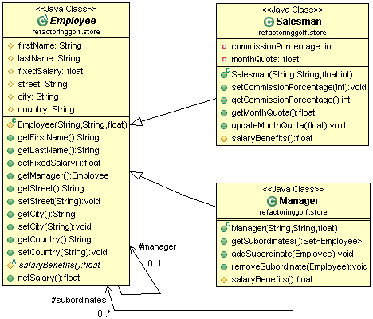

* **CODE**

public abstract class Employee {

protected String firstName;

protected String lastName;

protected float fixedSalary;

protected Employee manager;

protected String street;

protected String city;

protected String country;

protected Employee(String firstName, String lastName, float fixedSalary) {

this.firstName = firstName;

this.lastName = lastName;

this.fixedSalary = fixedSalary;

}

public String getFirstName() {

return firstName;

}

public String getLastName() {

return lastName;

}

public float getFixedSalary() {

return fixedSalary;

}

public Employee getManager() {

return manager;

}

public String getStreet() {

return street;

}

public void setStreet(String street) {

this.street = street;

}

public String getCity() {

return city;

}

public void setCity(String city) {

this.city = city;

}

public String getCountry() {

return country;

}

public void setCountry(String country) {

this.country = country;

}

**public float netSalary() {**

**float benefits = salaryBenefits();**

**float pensionFounds = this.fixedSalary * 10 / 100;**

**float tax = 0;**

**if (fixedSalary > 3500)**

**tax = fixedSalary * 5 / 100;**

**return fixedSalary + benefits - pensionFounds - tax;**

**}**

**protected abstract float salaryBenefits();**

}

public class Manager extends Employee {

**protected Set<Employee> subordinates = new HashSet<Employee>();**

public Manager(String firstName, String lastName, float fixedSalary) {

super(firstName, lastName, fixedSalary);

}

**public Set<Employee> getSubordinates() {**

**return Collections.*unmodifiableSet*(subordinates);**

**}**

**public void addSubordinate(Employee subordinate) {**

**subordinates.add(subordinate);**

**subordinate.manager = this;**

**}**

**public void removeSubordinate(Employee subordinate) {**

**subordinates.remove(subordinate);**

**subordinate.manager = null;**

**}**

**@Override**

**protected float salaryBenefits() {**

**return this.subordinates.size() * 20;**

**}**

}

public class Salesman extends Employee {

private int commissionPorcentage;

private float monthQuota;

public Salesman(String firstName, String lastName, float fixedSalary, int commissionPorcentage) {

super(firstName, lastName, fixedSalary);

this.commissionPorcentage = commissionPorcentage;

}

public void setCommissionPorcentage(int commissionPorcentage) {

this.commissionPorcentage = commissionPorcentage;

}

public int getCommissionPorcentage() {

return commissionPorcentage;

}

public float getMonthQuota() {

return monthQuota;

}

public void updateMonthQuota(float addQuota) {

monthQuota = monthQuota + addQuota;

}

**protected float salaryBenefits() {**

**return monthQuota * commissionPorcentage / 100;**

**}**

}